MANOR ROYAL BID MAINTENANCE TEAM ACTIVITY REPORT
Activity month | July 2021 |  | Baseline hours provided
Report date | 27/07/21 |  | Additional hours provided
Person | Darren Standing
Activities carried out ()
Road / area | Zone | Grass cutting | Litter picking | Weed control | Hedge cutting | Leaf clearance | Bin empty | Waste clearance | Pavement cleaning | Edging | Sign cleaning | Winter maintenance | Other
All areas | All | X3 | X4 |  |  |  | X13
Baird Close | 4
Betts Way | 1
Cobham Way | 5
County Oak Lane | 1
County Oak Way | 1
Crompton Way | 3
Faraday Road | 2
Fleming Way | Various
Gatwick Road | Various
Hydehurst Lane | 2
James Watt Way | 5
Jenner Road | 2
Kelvin Lane | 2
Kelvin Way | 2
London Road | Various
Manor Royal (road) | 2/3
Maxwell Way | 4
Metcalf Way | 1
Napier Way | 3
Newton Road | 2
Priestley Way | 5
Royce Road | 5
Rutherford Way | 5
Tinsley Lane | 4
Tinsley Lane North | 5
Wheatstone Close | 5
Whittle Way | 5
Whitworth Road | 5
Woolborough Lane | 3
Gateway 1 (Manor Royal) | -
Gateway 2 (near Thales) | -
Gateway 3 (near Astral) | -
Gateway 4 (James Watt) | -
The Terrace | -
Crawters Brook | -
Gatwick Road Parade | -
Woolborough Subway | -
Green Lane Subway | -

Main actions provided
With the weather and quick growing grass our priorities have been bins, litter and grass cutting, we have incorporated some of the path clearing within the grass cutting round, there has been a few locations of fly tipping with no evidence of where it was from highlighted in the locations above in the waste cleared section, we have utilised some of our other assets to help with some of the demand such as the Tractor team for grass collection and our Town Centre sweeper to help keep paths clear, we have been weed spraying various locations and will continue to do so weather permitting.

Comments and observations
No Comments to add at this time, however as time goes on and I familiarise myself with the area more observations will become clearer to help highlight any other issues that need to be raised.

Suggestions for future actions, improvements or additional activities planned
Our main focus at the moment is to continue with grass cutting, litter and bins in all zones with path clearing where possible and keeping the area clean and tidy, Weed spraying by WSCC is planned for 9th – 13th August, we will continue CBC spraying, we will have the tractor with the flail hedge cutter in the area within the next 8 – 10 weeks, to cut back some of the larger shrub areas around Tinsley Lane and Metcalf Way.

Photographic Impact Evidence (a selection of photos of work undertaken to demonstrate impact)
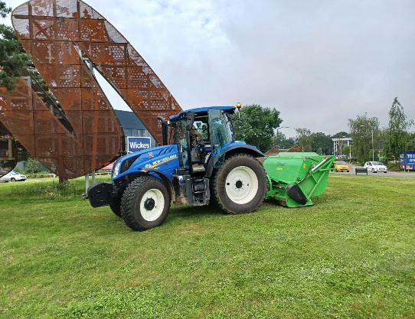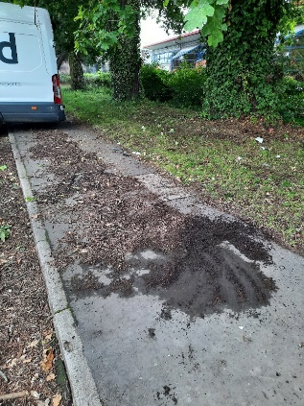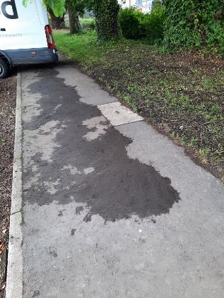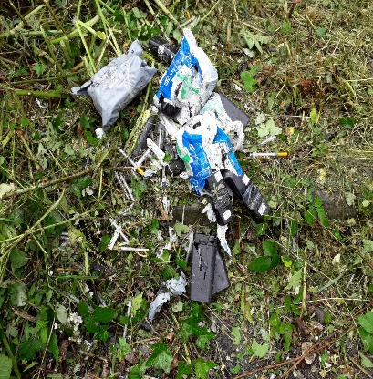

Details of CORE and ENHANCED Service levels (contract extract)

Current Baseline Service | Proposed | Enhanced element (* estimated)
Monthly litter pick (12 pa) | Weekly litter pick (52 pa) | X40 litter picks  + identify hotspots and trial extra bins
Weekly litter bin empty (52 pa) | Weekly litter bin empty (52 pa) | -
Monthly road sweep (12 pa) | Monthly road sweep (12 pa) | -
- | Remove fallen leaves and detritus from footpaths and common areas (4 pa) | X4 leaf and detritus removals
- | Washing and cleaning street furniture and signs to include street name signs, gateway / entrance signs, wayfaring signs and highways signs (2pa) | X2 washes
- | Deep cleaning/jet washing common areas, bus stops and paved areas (as required) | As required
Grass cutting (5 pa) | Grass cutting (12 pa) | * X7 grass cuts – (weather/ground conditions dependant)
Bunded/bank grass cutting (4 pa) | Bunded/bank grass cutting (10 pa) | X6 bunded/bank cuts
Hedgecutting (1-2 pa) | As required (2-3 pa) | * 1-2 Hedge cuts
Shrub maintenance (2-3 pa) | As required (4-5 pa) | * 1-2 shrub maintenance
Weed spraying (2 pa) funded by WSCC | Weed spraying (4 pa)  Removal of dead standing weeds (4pa)  Weed ripper as required | X2 weed sprays  X4 dead weed removals  Weed ripper as required  On footpaths and common areas
See note 1 | Box mow and maintain Gateway 3 Roundabout (10 pa) | X10 Box mow and maintain Gateway 3 Roundabout
- | Crawters Brook, The Terrace enhanced Maintenance (as Annex C) | Crawters Brook, The Terrace enhanced Maintenance (as Annex C)
- | Weekly inspection and rectification/reporting of faults found. | X52 inspections - reports/rectification of faults found
- | Reactive/response service through a single point of contact as required | Reactive/response service as required
- | Provide monthly information…  - feedback on what has been done and what is planned  - Available performance data - quantities such as volumes, lengths, waste weights etc. (tba)  - photographic evidence of before and after improvements,  - suggestions for further/future enhancements  - Attend meetings as required | X12 reports (monthly)
Notes: (1) There is a requirement for Gateway 3 and Crawter’s Brook People’s Park to be maintained to a basic level as described in the Annexes.

